Russian-Ukrainian War Conundrum and the Way Forward
Lieutenant General Sunil Kumar Gadeock, AVSM (Retd)

Byline:
India can act as an intermediary between Russia and Ukraine by facilitating the requisite conversations between the conflicting nations, moderating the humanitarian impact of the conflict, and helping assuage the economic damage this present conflict has caused in the Global South.
Background
The principal threat to peace, development, and security in Europe in the post-Cold War world has been Russia’s military operations against Ukraine since February 2022. There are no diplomatic or bilateral relations between Russia and Ukraine, only acute bellicosity and greater hatred as both nations have been in confrontation since Russia’s invasion of the Crimean Peninsula in February 2014. The long-simmering disagreement is related to the North Atlantic Treaty Organisation’s (NATO) enlargement in Europe and the legitimacy of Ukrainian identity and statehood. The latter disagreement suggests that the modern nation-states of Russia, Ukraine, and Belarus should have a common political destiny, presently and going forward into the future. A claim is asserted that the diverse Ukrainian and Belarusian identities are the product of foreign manipulation and the West is incorporating Ukraine (and Belarus) into an “anti-Russia project.”
Historical Perspective and Triggers of Aggression
According to Russian President Putin, Russians, Ukrainians, and Belarusians are all descendants of Ancient Rus, which was the largest state in Europe in ancient times. Slavic and various other tribes spanning across Ladoga, Novgorod, Pskov, to Kyiv and Chernihiv, were linked together through one language (which is now often referred to as the Old Russian), along with the economic ties, the rule of the princes of the Rurik dynasty after the baptism of Rus (the Orthodox faith). Also, Kyiv held a dominant position in Ancient Rus, which was a custom since the late 9th century. The term “Ukraine” was often used to denote the meaning of the Old Russian word “Okraina” (periphery).
Following the dissolution of the Soviet Union, several of its former republics declared their independence. In August 1991, Ukraine emerged as an independent sovereign nation after seventy years of totalitarianism. It had suffered in the civil war during the Bolshevik revolution, famine in the 1930s, the ruthless Nazi occupation, the holocaust of World War II, and political expulsions and stagnation in the Soviet era. The Ukrainian declaration was ratified by a majority referendum, and Leonid Kravchuk was elected as its first president. However, after the independence from the Soviet Union, the Ukrainian economy suffered from shortages, blackouts, inflation, and spiking emigration. A considerable rise in its economic prosperity between 2004 to 2007 coincided with its aspirations for a stronger democratic process.
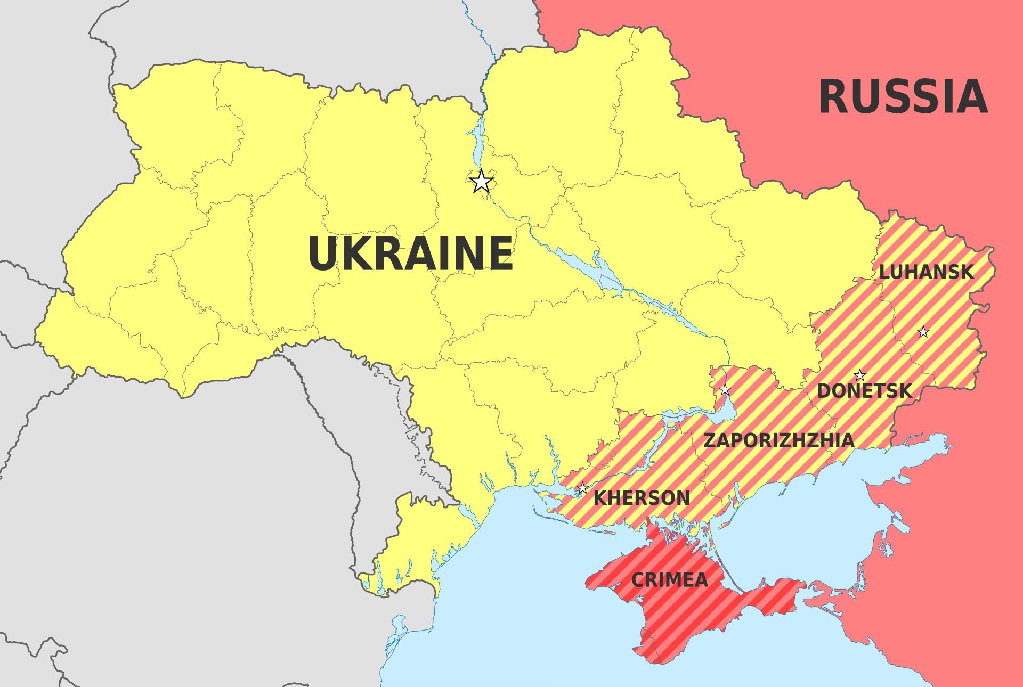
Ukrainian exports were still reaching Russia, including the top security positions that were held by people with Russian passports. In fact, Ukraine had undeclared propensities in a multispectral domain towards Russian material resources and signed a deal for natural gas trade in 2008. This committed Ukraine to being the largest purchaser of Russian gas, that too at a higher cost than the market price. Insofar as defence was concerned, it should be noted that the Russian Navy’s Black Sea fleet continued its presence in Crimea. This was done at Russia’s insistence to prevent Ukraine from joining NATO.
The Russian geostrategic interest in Ukraine and numerous other geopolitical factors acted as the primary trigger for this current Russia-Ukraine conflict. During the Cold War, the Soviet Union maintained strong control over Ukraine while dealing with financial crises and Western interference in its critical territorial security areas. Russia has been overly sensitive and concerned about being encircled by NATO and the European Union (EU). As a result, President Putin was eager to extend his influence and create strategic buffer zones in terms of the land surrounding Russia’s land borders. Secondly, the Russian idée fixe on acquiring Ukraine's rich resources, such as oil, gas, and crops, is also seen as a factor behind the present crisis. As Russia is deeply concerned about increasing Western influence in the Eurasian region, it will not be an overestimation to say that Russia considers Ukrainian territory as a region necessary for its geostrategic depth. Thirdly, the presence of a large ethnic Russian population, practicing Orthodox Russian Christianity in Ukraine, has religious, economic, and cultural roots with Russia. Fourthly, following the disintegration of the Soviet Union, the West has maintained its watch on countries formed after the disintegration and launched policies to bring about reforms in these nations through the promotion of democracy and human rights preservation. Fifthly, various indigenous or local ethnic and economic issues have acted as significant triggers for the continuing conflict between Russia and Ukraine.
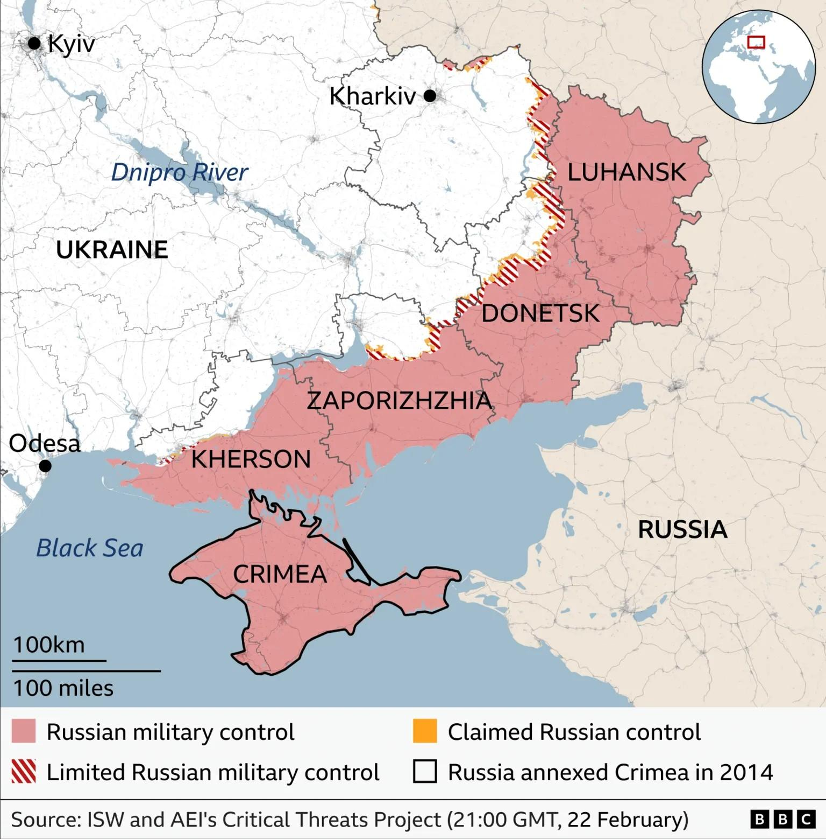
However, Ukraine has perceived that the economic relations with the Western nations, including the United States, would provide more economic gains as compared to its relationship with Russia, even when it understood that Russia was reluctant to lose its circle of influence. Moreover, Ukrainian social structure consists of several ethnic minorities, and Russia providing military and economic support to ethnic Russian groups residing in Southeast Ukraine, like Donbas and Luhansk regions, acted as a sore point for Ukraine.
Furthermore, Ukraine's aspiration to join NATO and the EU has long been viewed by Russia as a threat to its security and strategic position, ostensibly an expansionist strategy towards gaining an ascendant military posturing against Russia. The possibility of Ukraine strengthening ties with Western alliances pushed Russia to take assertive actions to prevent this perceived encroachment. Ukraine’s initial steps to join NATO are one of the primary factors for the Russian invasion of Ukraine in February 2022. The eastward expansion of NATO is specifically the reason that inflamed Russian President Putin.
Additionally, the political instability or a weak central government in Ukraine was considered by Russia as an opportune moment to intervene. Russia cited the need for political stability and safety and security of the Russian-speaking populations or ethnic Russians residing in Ukraine as the primary motives for its intervention. This can further be associated with the tensions in the Eastern Ukrainian districts, particularly in Donetsk and Luhansk, which have been a source of contention. Also, between September 2014 and February 2015, Russia, Ukraine, France, and Germany signed the Minsk agreements. This eventually led to the stopping of the forward movement of troops and a substantial decrease in fighting.
Ukraine is a crucial transit route for Russian gas exports to Europe. Despite the ongoing military conflict between Russia and Ukraine, Russian gas transfer to Europe through Ukraine continues despite the current contentious situation between the two nations at a rate of 35–40 million cubic meters per day (mcm/d). This figure is lower in terms of the volume of gas transferred from the pre-conflict levels. The Ukrainian gas transmission system is linked with four EU member states, i.e., Poland, Slovakia, Hungary, Romania, and Moldova. Between 2022 and 2023, six EU nations, namely Slovakia, Austria, Italy, Hungary, Slovenia, Croatia, and Moldova, received Russian gas through this Ukrainian transit corridor. It remains ironic that in the midst of Russia’s invasion of Ukraine, Russian oil and gas continue to flow through Ukrainian pipelines. Before this conflict began in 2022, Europe had relied on Russian gas, with almost 40-45 percent of its imported gas and about a quarter of its oil reaching Europe through these pipelines.
Russia has time and again communicated its apprehensions and subsequent dissatisfaction regarding this NATO enlargement during diplomatic meetings and encounters. So, the ongoing conflict initiated by Russia against Ukraine can be interpreted as a Russian reaction.
Road to Conflict: Apprehensions of the USA and EU
The American and EU sanctions made sustenance difficult for the Russian economy, especially with most of its banking and financial institutions suffering from these sanctions due to a lack of access to the prevalent dollar-denominated financial system. Historically, before the Orange Revolution, President Putin had assumed that a large number of Ukrainians remained committed to the idea of the “all-Russian” nation and that it was only the manipulation of foreign powers that had pushed Ukraine away from Russia.
In this continuing conflict, Russia has failed to accomplish any of its stated military aims, along with suffering significant losses both in terms of troops and equipment. Even apolitical Ukrainians have fought back or condemned the invasion. The long list of supporters that the Russians were counting on could not be materialised. Russian determination to bring Ukraine back into the fold despite the huge economic cost playing through this conflict indicates that the present crisis goes beyond the issue of Ukraine’s relationship with NATO. The outcome of the conflict will ultimately depend on the West’s response and Ukraine’s inclination to fight for itself.
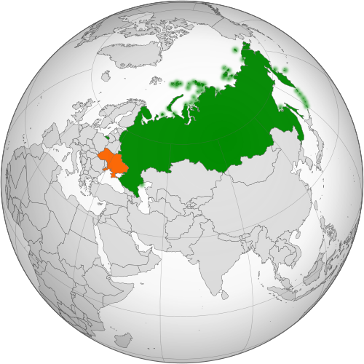
Since February 2022, the United States has imposed economic sanctions on almost 1,900 Russian individuals and entities, along with an entry ban on several thousand Russian officials, military personnel, government-linked personnel, Russian businessmen, and others into the United States. The American Congress has supported the enhanced force presence and American leadership of NATO defence and deterrence measures. The American Senate also gave its advice and consent to approve Finland and Sweden’s accession to NATO. The EU has also imposed sanctions on Russia, following American sanctions. These sanctions encompass travel bans, asset freezes, and restrictions on economic cooperation, particularly targeting sectors like finance, energy, and defence. Both the United States and the EU have provided political, financial, and humanitarian support to Ukraine. The United States and the EU have been actively engaged in diplomatic efforts to find a peaceful resolution to the conflict. They have supported the Minsk agreements, negotiated within the framework of the Organisation for Security and Cooperation in Europe (OSCE), aimed at achieving a ceasefire and a political settlement in eastern Ukraine. President Putin’s statement to the press in June 2022 that “There is nothing to worry us in terms of Swedish and Finnish membership of NATO” suggests a different view that NATO’s enlargement may have caused no such deep concern for Russia.

India’s Strategies and Workable Options
India, recognised for its adherence to non-interference in the internal affairs of any nation, has had to tread carefully when it comes to supporting Russian military actions and aggressiveness, putting it in a tight spot. There was a mutual diplomatic support between the two nations, with the Soviet government supporting India’s claim to Kashmir and India voting with or abstaining against Soviet actions during key Cold War events, including the 1968 Soviet invasion of Czechoslovakia. Meanwhile, India was one of the first countries to recognise Ukraine as a sovereign country in December 1991 and established diplomatic relations in January 1992. Ukraine opened its Mission in Delhi in February 1993, which was also Kyiv’s first diplomatic mission in Asia. In 1992, India and Ukraine signed the Treaty on Friendship and Co-operation, which provided a boost to bilateral relations between the two nations.
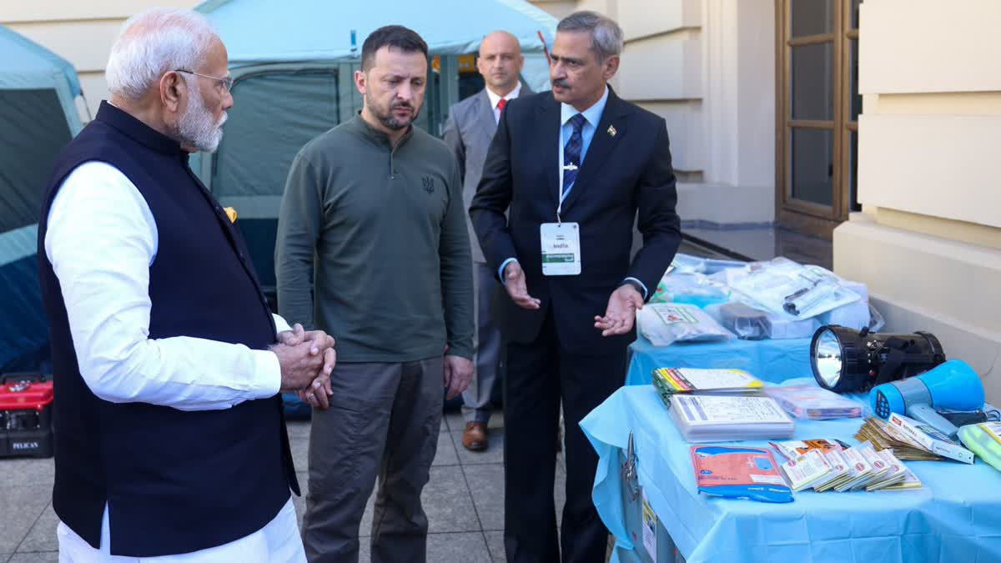

India, being a significant global player and having historical ties with both Russia and Ukraine, faces complex choices and options in the ongoing conflict. Its approach aims to balance various considerations, striving towards everlasting peace and stability equilibrium in the Eurasian region, including strategic partnerships, energy security, economic interests, and adherence to international norms. India has been visualised as a reliable strategic partner of Russia, wherein the latter has supported it at the United Nations and played a vital role in contributing to building up Indian military multidimensional capabilities and providing India the space to exercise strategic autonomy vis-à-vis the West.
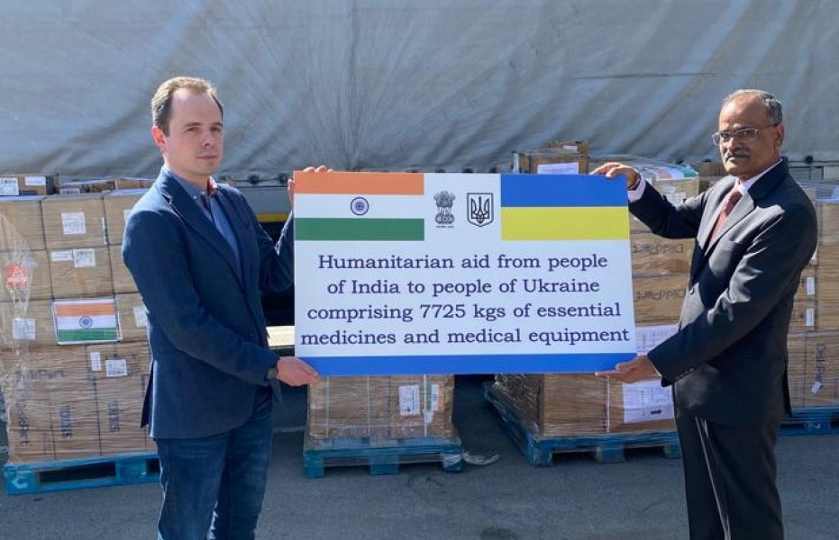

Furthermore, India weighs in its economic interests and energy security concerns, considering its significant imports of defence equipment, energy resources (like oil and gas), and other trade relations with Russia. This, India has been able to carefully manage crisis precipitation through well-calibrated responses while strategically balancing its partnerships. It had been banking on lucrative military contracts with Russia to help boost its own defence industry, but unfortunately, Russia has been prioritising its own military needs necessitated by the ongoing war, leaving India to look elsewhere to further consolidate its strategic national interests.
India’s emerging camaraderie with the US has significantly enhanced the nation’s rising prominence, whereas Russia has drawn closer to China. Also, Russia’s growing strategic dependence on China could lead India to deepen its relations in various strategic domains with the US. During President Putin’s visit to India in December 2021, both nations rekindled their commitment to a “special and privileged strategic partnership.” For instance, India’s nuanced posture toward Russia was further reaffirmed by Moscow hosting a military exercise, Vostok 2022, in August-September 2022, alongside China and several other nations. The exercise reportedly involved 50,000 troops, more than 140 aircraft, and 60 warships. So, it can be said that India-Russia relations have undergone a rebalancing. The balance in the relationship has shifted decidedly in India’s favour.

Prospects for Peace in an Ongoing Turbulent Environment
- India must uphold its tradition of non-alignment policy and promote a neutral, non-confrontational approach to actively engage with a highly optimised diplomatic strategy, offering to mediate or facilitate constructive dialogues between Russia and Ukraine to cease operations and encourage peaceful negotiations through instrumentation of Indian declared policy of ‘Strategic Autonomy.’
- The UN must play a pivotal strategic role and initiate a ‘No War Pact’ between Russia and Ukraine, at a specially convened session of the United Nations General Assembly for the purpose. India, known for its active role in UN peacekeeping missions, can largely contribute by providing a leadership role.
- India can reiterate its commitment to international norms and principles of sovereignty and territorial integrity, urging its key allies and like-minded strategic partners, viz., the EU, NATO, the United States, and its allies in the world, to get involved and pledge peace initiatives.
- India can utilise other viable multilateral platforms, viz., the Shanghai Cooperation Organisation (SCO) or BRICS, to actively engage in discussions regarding the conflict.
- India can accentuate its ‘soft power’ dynamics by providing humanitarian assistance to the affected regions economically with myriad welfare measures, showcasing India's incessant commitment to humanity.
- Furthermore, New Delhi can enhance economic and diplomatic ties with Ukraine in its quest for reconstruction of schools and medical institutions, without antagonising Russia, which will help in highlighting India’s balanced approach to ‘Philanthropic Post War Diplomacy’. This posturing would also showcase an evolving, flexible responsiveness and a dynamic symbiosis with the EU and Western nations, while largely respecting the interests of all parties involved.
- India must play a decisive role to ensure that certain “confidence-building measures” are administered between the forces, which would serve to build the desired trust and begin the reconciliation process between the defence forces of the warring nations. At the same time, disarmament, demobilisation, reintegration, and downsizing of forces should be done.
- Undertaking humanitarian measures comprising demining and protection of civilians, a process for dealing with prisoners of war and political prisoners, logistical supplies of consumer items, movement of goods, and security of installations is significant to prevent the collapse of the administrative system. Governments are incumbent to carry out seamless ‘fast track’ high-trust activities to instill confidence in the people to restore normalcy in the region.

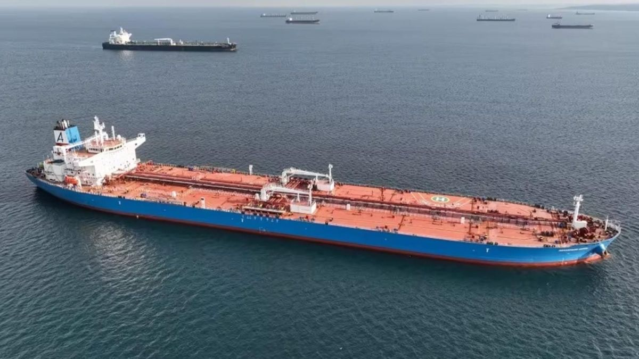

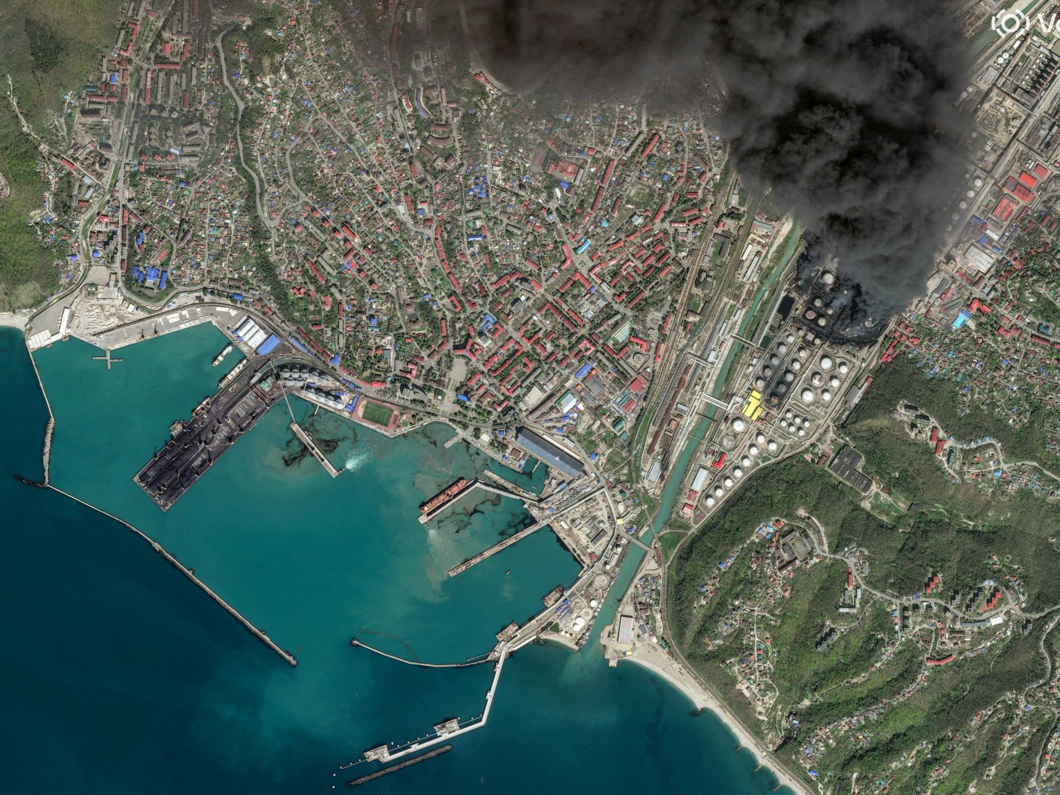

Through this, India can act as an intermediary between Russia and Ukraine by facilitating the requisite conversations between the conflicting nations, moderating the humanitarian impact of the conflict, and helping assuage the economic damage this present conflict has caused on the Global South. India should not shy away from presenting itself as a credible arbiter and emphasising its ideas in a conflict.
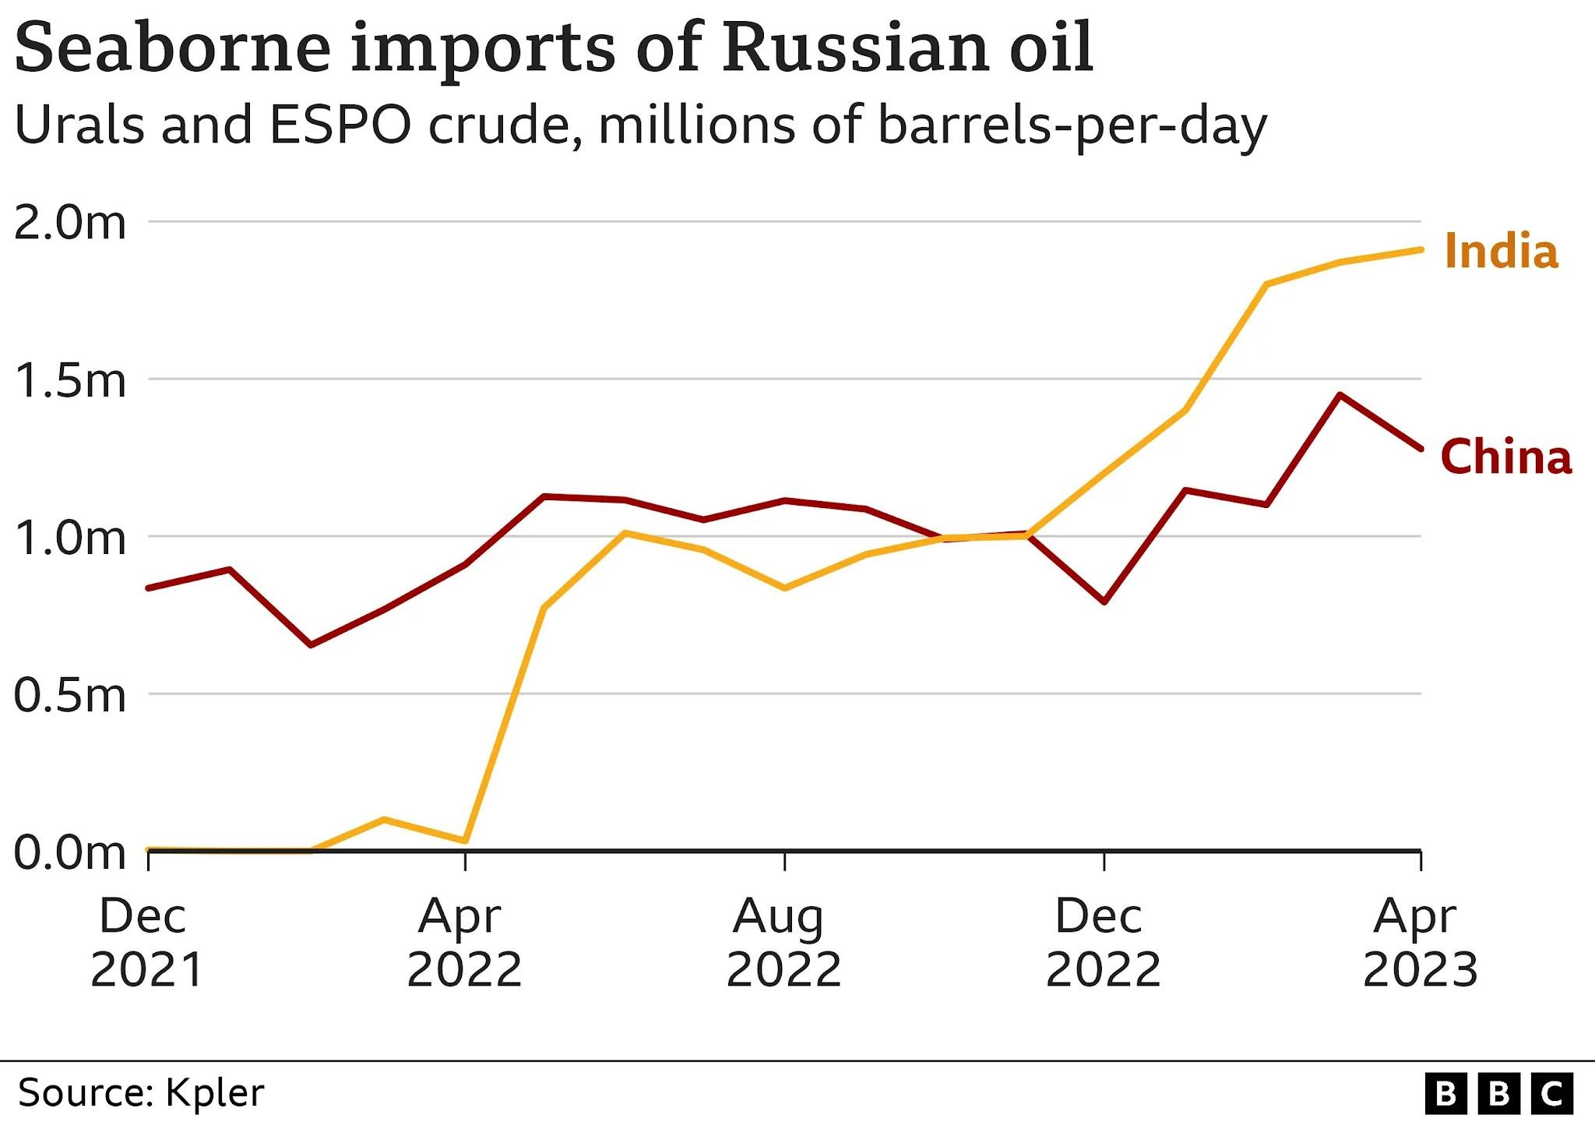
The Russia-Ukraine war has adversely affected the Indian economy through its negative consequences on trade, such as coal, oil, natural gas, and other commodities, viz., steel, cotton, and wheat from Russia, and import of highly valuable energy sources such as nuclear fuel from Ukraine. The war has led to disruption in these trade rotations due to augmented tariff rates and sanctions, leading to higher prices and diminished accessibility of these commodities in India. This had spiralling effects on the livelihood of people, their economic prosperity, and resources. It has impeded access to reliable and inexpensive communication systems, as the Eurasian region contains most of the undersea communication cables in the world that form the backbone of the internet.
These cables are necessary for the proper functioning of global information technology networks and services, with serious repercussions on download and upload speeds, data security, and other internet–driven services. This has also directly impacted the process of international trade and has been an issue for Ukraine and Russia, which produce an enormous share of global exports of wheat, resulting in natural deterioration of vast stocks at Ukrainian ports. Resentment and protracted discord between the countries caused prices of diesel, petrol, wheat, vegetable oils, and many other commodities to increase rapidly. Additionally, the war has resulted in a resurgence of terrorism, which has caused increased security costs with deterrent problems related to progressive growth-oriented development and a desired robust economy.
India’s diplomatic finesse and manoeuvrings were showcased through the G20 summit that was successfully organised in September 2023. In this context, India, with its enhanced global profile and successful G20 Presidency, can contribute significantly to bringing this ongoing conflict between Russia and Ukraine to an end. In this, the US can be India’s partner, as it has iterated that it hopes to work with its partners and allies around the world. India's approach should reflect its commitment to global peace, stability, and adherence to international norms while safeguarding its strategic interests and fostering constructive relationships.

Conclusion
The conflict between Russia and Ukraine has had broad and extensive implications for the global economy, food security, and the basic principles outlined in the United Nations Charter on sovereignty and territorial integrity. The Russia-Ukraine conflict has further affected the supply chains, resulting in price escalations of various commodities, including oil, gas, and food. The Ukrainians in early March 2022 sought to negotiate an end to the conflict and offered to accept neutrality. However, the Ukrainian government’s position hardened later in March 2022 when Russian atrocities came to light. It hardened the Ukrainian government’s position.
The ravages of this ongoing conflict have been heartbreaking, especially the unprecedented cost-effective drone warfare employed in concert with missiles and fighter aircraft, which are creating unimaginable casualties with so many precious human lives lost, displacement of humanity, and property damaged beyond recognition, ecosystem ruined, the scars would persist for decades as a grim reminder of non-commiseration to the brutality and atrociousness of human minds. The UNGA has to be proactively engaged in these multifaceted peace initiatives. UNPKF should be consolidated towards optimising peacekeeping efforts in Eurasian war-ravaged areas between the countries.
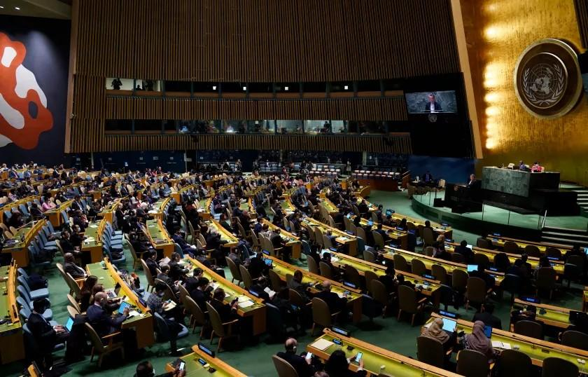
Reconstruction work has to be prioritised by the UNGA to a UN Peace Committee, something similar to the proposal made by the USA on its ‘Marshall Plan’ supported by the UNGA after the Second World War, for a fast-track reconstruction process of Europe devastated during World War II. The UN Secretary General would require to monetarily strategising and impress upon all member nations to donate positively with a generous intent for the war-ravaged nations, especially Ukraine, whose infrastructure was damaged due to the incessant Russian firepower assaults on civil amenities to resurrect humanity. This would also apply equitably to the Russian infrastructure, as conforming to the recommendations by the relevant appointed UN Peace Committee to investigate and implement the same within the enunciated pragmatic parameters in an acceptable timeframe.
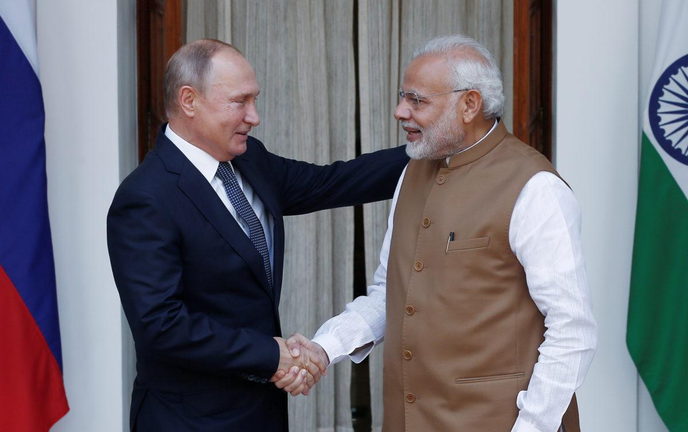
The modus operandi would have to be worked out by the UN Peace Committee and amongst the nations that are at war. Normalcy would have to be encouraged not only by the UNGA, but also through heads of state of various donor member nations for expediting recovery processes and invigorating philanthropic projects created by generous people and affected nations, with adequate dispensations being given to such nations, conforming to the tenets of the Reconstruction Plan. All donations through Corporate Social Responsibility (CSR) given by multinational corporations/ government agencies are to be registered and given the due exemptions as per CSR guidelines.

